

**BOOK LIBRARY**

**Software Requirement Specification**

– Hanoi, January 2023 –

**Record of changeS**

| **Date** | **A* M, D** | **In charge** | **Change Description** |
| --- | --- | --- | --- |
| 31/Jan | A | TrangVT | Thêm mô tả chức năng Login (II.1.a) |
| 01/Feb | A | HuyNQ | Thêm mô tả chức năng quản lí Profile (customer) (II.2) |
| 02/Feb | A | VuVT | Thêm mô tả chức năng Dashboard (II.3.a) |
| 05/Feb | A | VuVT | Thêm mô tả chức năng trang chủ (II.4) |
| 07/Feb | A | QuyenKTH | Thêm mô tả chức năng quản lí Product (II.5) |
| 10/Feb | A | ThanhDC | Thêm mô tả chức năng quản lí Order |
| 10/Feb | A | VuVT | Thêm mô tả chức năng quản lí giỏ hàng |
| 12/Feb | A | VuVT |  |
|  |  |  |  |
|  |  |  |  |
|  |  |  |  |
|  |  |  |  |

*A - Added M - Modified D - Deleted

**Table of Contents**

I. Overview **4**

1. Introduction 4

2. System Functions 5

a. Screen Flow 5

b. Screen Details 5

c. User Authorization 6

d. Non-Screen Functions 6

3. Entity Relationship Diagram 7

4. Use Case Diagram 8

II. Functional Requirements **10**

1. Login 10

2. Home page 12

3. Profile 13

4. Dashboard 16

5. Products 18

6. Orders 19

7. Cart 21

# I. Overview

## 1. Introduction

Book Library is a website that allows users to buy books through online libraries. Book Library helps save customers' shopping time, increasing the shopping experience with a variety of book genres. Book Library is developed with features such as high discount coupon codes, customer information protection, shopping recommendations, etc. Helping customers easily choose and increase authenticity. With quick updates, Book Library always puts the customer's experience first.

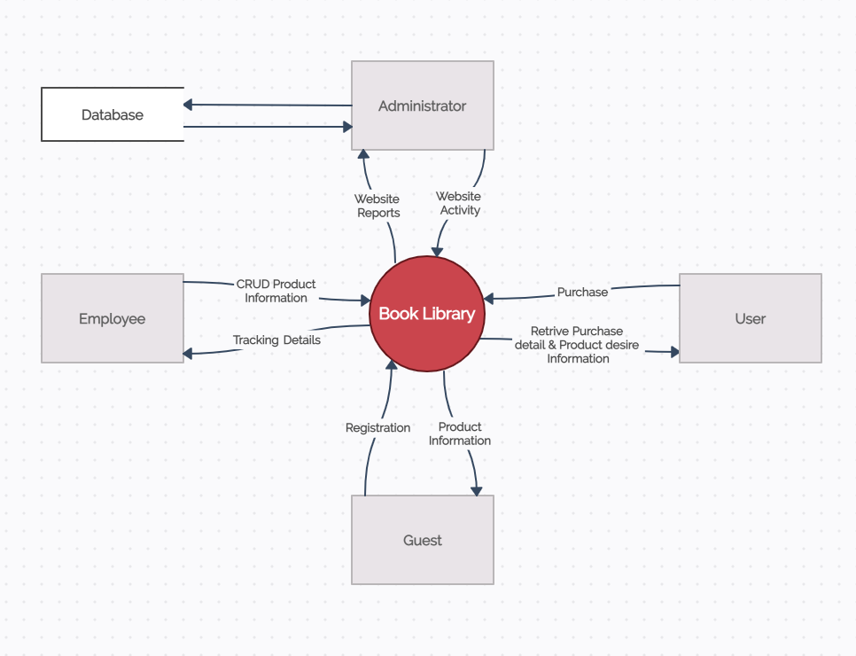Book Library’s System Context Diagram

## 2. System Functions

#### a. Screen Flow

* Admin Screen Flow

## 

* User Screen Flow

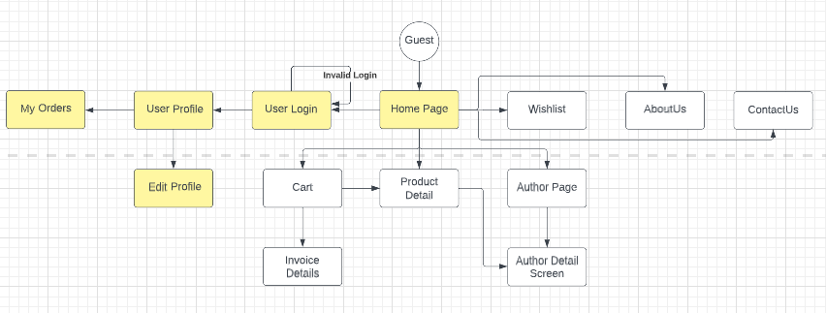

#### b. Screen Details

| **#** | **Feature** | **Screen** | **Description** |
| --- | --- | --- | --- |
| 1 |  |  |  |
| 2 |  |  |  |
| 3 |  |  |  |
|  |  |  |  |

#### c. User Authorization

| **Screen** | **Admin** | **Employee** | **Customer** | **Guest** |
| --- | --- | --- | --- | --- |
| Login |  |  |  | X |
| Home |  |  | X | X |
| Products |  |  | X | X |
| Product Details | X | X | X | X |
| Profile_Customer |  |  | X |  |
| Profile_Customer_Edit |  |  | X |  |
| Cart |  |  | X |  |
| Order Action |  |  | X |  |
| My Order |  |  | X |  |
| Wish List |  |  | X |  |
| Profile_admin | X | X |  |  |
| Profile_admin_edit | X |  |  |  |
| Dashboard | X |  |  |  |
| Order_Management | X | X |  |  |
| Product_Management | X | X |  |  |
| Product_Manegement_Create Product | X | X |  |  |
| Product_Manegement_Edit Product | X | X |  |  |
| Employee_Management | X |  |  |  |

In which:

* **Admin**: (Administrator) a person who logged in the website by admin account
* **Employee**: a person who logged in the website by employee account
* **Customer**: A client who logged in the website by a normal account
* **Guest**: Someone access to website but still not login

#### d. Non-Screen Functions

*[Provide the descriptions for the non-screen system functions, i.e batch/cron job, service, API, etc.]*

| **#** | **Feature** | **System Function** | **Description** |
| --- | --- | --- | --- |
| 1 | Common | User Logout | Close session for current user and redirect to homepage |
| 2 | Customer | Google authentication | Use Google Authentication API to verify user |
| 3 | Customer | Facebook authentication | Use Facebook Authentication API to verify user |
| 4 | Admin | Delete Product | Remove a product from system |
| 5 | System | Security | Just use session storage to save user’s data |
|  |  |  |  |

## 3. Entity Relationship Diagram

*[Provide the entity relationship diagram and the entity descriptions in the table format as below]*

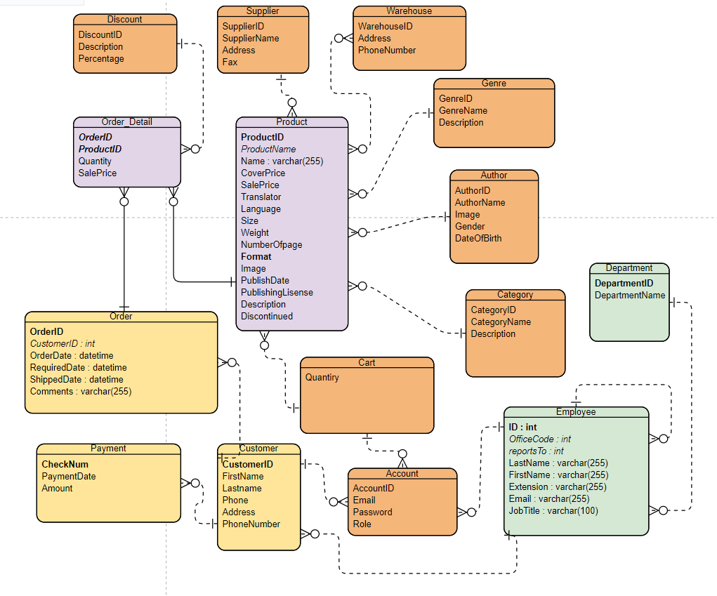

**Entities Description**

| **#** | **Entity** | **Description** |
| --- | --- | --- |
| 1 | Product | Main object is book |
| 2 | Customer | Consumer, who want to buy book |
| 3 | Employee | Manager, saler perform business operation |
| 4 | Account | The registered user of the system |
| 5 | Order | Record information about an order |
| 6 | Order Detail | Record more detail in an order |
| 7 | Category | Classify book by categories |
| 8 | Genre | Classify book by Genres |
| 9 | Warehouse | Repository to store book, perform send book to customer |
| 10 | Supplier | Publisher will print book and supply them into the market |
| 11 | Discount | Store information about voucher |
| 12 | Cart | Store book which customer want to buy |
| 13 | Payment | payment method of customer |
| 14 | Department | Classify employee into department, admin/saler…etc |

## **4. Use Case Diagram**

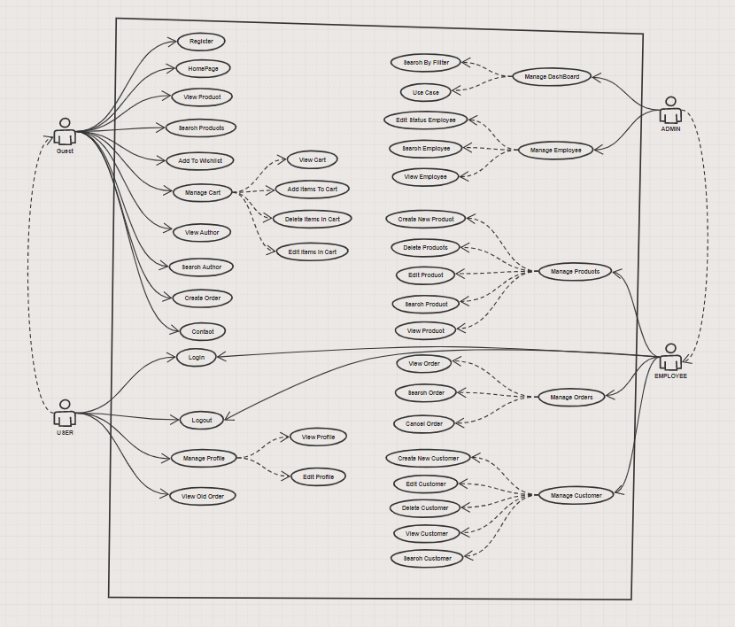

| **ID** | **UseCase** | **Actor** | **Use Case Description** |
| --- | --- | --- | --- |
| 01 | Manage DashBoard | Admin | This function allows Admin to track the revenue of the web, track the level of revenue over the time period that the admin wants to see |
| 02 | Manage Employee | Admin | This function allows Admin to manage employees working in the store |
| 03 | Manage Products | Employee | This function allows Employee to manage the products in the store and keep track of the number of products |
| 04 | Manage Order | Employee | This function allows Employee to manage orders placed in the store, including order date, quantity |
| 05 | Manage Customer | Employee | This function allows Employee to manage customer information coming to the store |
| 06 | Register | Guest | This function allows buyers to register personal information to proceed with ordering and purchasing |
| 07 | Login-logout | Employee,User | This function allows Employee and User to log in and out of the store's system |
| 08 | Manage Profile | User | This function allows User to manage personal information, change personal information |
| 09 | View Old Order | User | This function allows User to manage their orders in the system, add orders and cancel orders in the system |

# II. Functional Requirements

## 1. Login

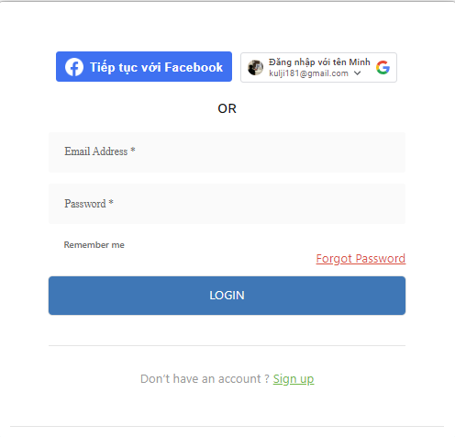

Figure 1: Login form

| ID and Name: | 01 | Actor: | Customer |
| --- | --- | --- | --- |
| Description | This allows users to login into their account(s). Users can also login by Google account, reset password in case they forget and sign up if they don’t have an account. | | |
| Trigger: | Actor clicks the Login button and makes a login. | | |
| Precondition: | None | | |
| Post-conditions: | The system displays their information ( name, picture profile,..) to the homepage. | | |
| Normal flow: | Actor actions | | System response |
| 1. The user(s) go(es) into the homepage and click on the login button. 2. The user(s) input their email and password of their registered account(s) or login by social media accounts.   The use case ends. | | 1. The system pop-up login form to login 2. The system checks for accounts and the user(s) will be redirected to the dashboard, otherwise the user has to correctly input their account(s). |
| Alternative Flows: | 2a. The session is out of date:   1. The systems redirect to login page 2. Use case resumes at main flow step 1   2b. The AccountID invalid: (AccountID of Staff or AccountID inactive):   1. The systems redirect to login page 2. Use case resumes at main flow step 1   2c. The email or password is wrong:   1. Redirect login page with notifying message “Your email or password is wrong. Try again!” 2. Use case resumes at main flow step 1   2d. User forgot password:   1. The system will send an email of a new password to user email 2. Use case resumes at main flow step 1   2e. User sign up:   1. The system will redirect user to register page 2. User sign up new account and verify the email   Use case resumes at main flow step 1[1] | | |
| Exception Flows | N/A | | |
| Business Rules: |  | | |

## 2. Home page

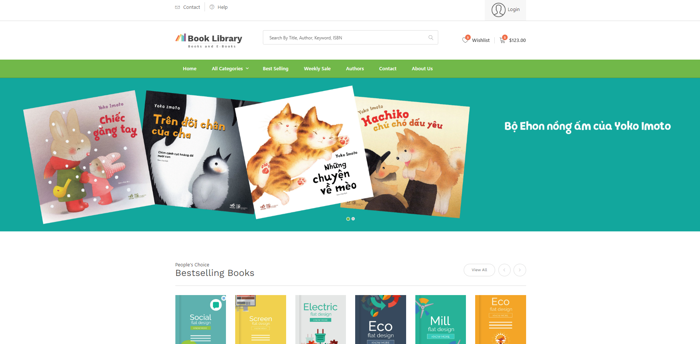

Figure 2: Homepage

| ID and Name: | 02 | Actor: | Customer |
| --- | --- | --- | --- |
| Description | This allows users to quickly view product’s information in the system such as name, price, author,... and view the website’s services. | | |
| Trigger: | Users access the path homepage or click on the “Home” button on the navigation bar | | |
| Precondition: | None | | |
| Post-conditions: | The system displays homepage | | |
| Normal flow: | Actor actions | | System response |
| 1. The user login successful or go to URL or click to the Dashboard button   The use case ends | | 1. The system display dashboard page |
| Alternative Flows: |  | | |
| Exception Flows | N/A | | |
| Business Rules: |  | | |

## let's fill in the blank.

this is function “logout”

| ID and Name: |  | Actor: |  |
| --- | --- | --- | --- |
| Description |  | | |
| Trigger: |  | | |
| Precondition: |  | | |
| Post-conditions: |  | | |
| Normal flow: | Actor actions | | System response |
|  | |  |
| Alternative Flows: |  | | |
| Exception Flows |  | | |
| Business Rules: |  | | |

## LogOut:

1.Logout

| UC ID and Name: | UC-01: Logout Function | | |
| --- | --- | --- | --- |
| Created By: | Cuongnd | Date Created: | 24/02/2023 |
| Primary Actor: | Logged-in User | Secondary Actors: |  |
| Trigger: | The user selects the "Logout" option from the application menu. | | |
| Description: | The Logout function allows a logged-in user to end their current session and return to the login screen. | | |
| Preconditions: | The User must be logged into the system | | |
| Postconditions: | The user's session is terminated , and they are returned to the login screen | | |
| Normal Flow: | 1. User selects the “Logout” option from the application menu 2. System prompts the user to confirm their decision to log out. 3. User confirm their decision 4. System logs out the user and ends their session 5. System displays the login screen | | |
| Alternative Flows: | None | | |
| Exceptions: | None | | |
| Priority: | High | | |
| Frequency of Use: | Frequent | | |
| Business Rules: | None | | |
| Other Information: | None | | |
| Assumptions: | Assumptions | | |

2. check the progress employee’s

| UC ID and Name: | UC-01: Check Employee Work Progress | | |
| --- | --- | --- | --- |
| Created By: | Cuongnd | Date Created: | 24/02/2023 |
| Primary Actor: | supervising attorney | Secondary Actors:  Associate Attorney |  |
| Trigger: | The supervising attorney requests to check the progress of an associate attorney ‘s work on a case | | |
| Description: | The supervising attorney needs to keep track of an associate attorney’s progress on a case , and requests to view this information | | |
| Preconditions: | The supervising attorney must be logged in to the law firm’s case management system.  the associate attorney must have a case assigned and in progress | | |
| Postconditions: | After finishing this function, the supervising attorney will be able to view the progress of the associate attorney’s work on the case | | |
| Normal Flow: | 1. The supervising attorney logs in to law firm’s case management system 2. The supervising attorney navigates to the case progress tracking page. 3. The supervising attorney selects the case they want to check progress for. 4. The supervising attorney selects the associate attorney they want to check progress for. 5. The system displays progress information for the selected case including any task assigned to the associate attorney , their current status and additional notes and comments. | | |
| Alternative Flows: | if the supervising attorney does not have permission to view the progress of selected associate attorney, an error message is displayed | | |
| Exceptions: | if the associate attorney does not have any task assigned to the selected case, an error message is displayed. | | |
| Priority: | High | | |
| Frequency of Use: | Daily | | |
| Business Rules: | Only Supervising attorneys with proper permission can view the associate attorney progress information.  Information progress should be updated regularly by the associate attorney. | | |
| Other Information: | N/A | | |
| Assumptions: | The law firm’s case management system has a database to store cases and the employee progress information.  The associate attorney has already logged their progress on the assigned case and task in the case management system. | | |

## 3. Profile

a, customer information

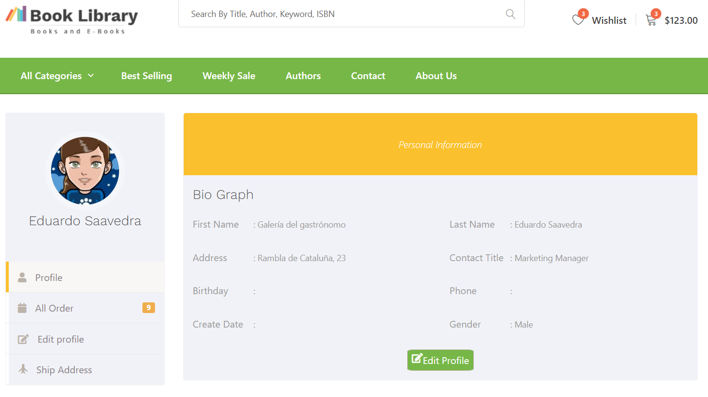

| ID and Name: | 02 – Manage personal profile | Actor: | Customer |
| --- | --- | --- | --- |
| Description:  Trigger: | The system displays the user's information. | | |
| the UUser wants to see the personal information stored in the system | | |
| Precondition: | PRE_1: Actor has logged into the system. | | |
| Post-conditions: | POST_1: The system displays account information. | | |
| Normal flow: | Actor actions | | System response |
| 1. Click on the avatar icon in the  navigation bar.  3. Click on the “Thông tin cá  nhân” hyperlink in the menu. | | 2. Display a drop-down menu.  4. Display user information page |
| Alternative Flows: | N/A | | |
| Exception Flows | 4.1 The user is not logged in and the system asks for login | | |
| Business Rules: |  | | |

b, Update profile

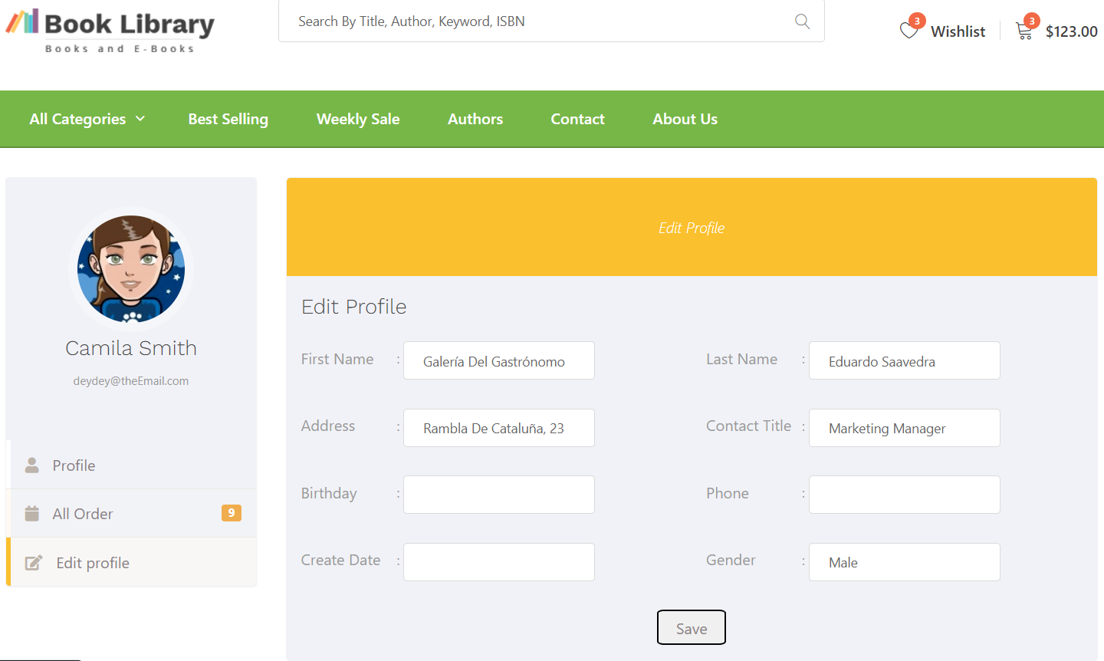

| ID and Name: | 03 – Update profile | Actor: | Customer |
| --- | --- | --- | --- |
| Description:  Trigger: | This function allows the actor to update personal profile. | | |
| The user wants to change the information stored in the system | | |
| Precondition: | PRE-1. Actors have been logged into the system.  PRE-2. Actors access personal profile screen | | |
| Post-conditions: | POST-1. The system displays the user's personal information. | | |
| Normal flow: | Actor actions | | System response |
| 1. Edit the actor’s information wants to change.  2. Click on the “Save” button | | 3. Display message: “Successful Update Information” |
| Alternative Flows: | N/A | | |
| Exception Flows | 3.1 The user enters incorrect information and the system returns a message instructing the user to re-enter it | | |
| Business Rules: |  | | |

c, Manage Customer’s Order

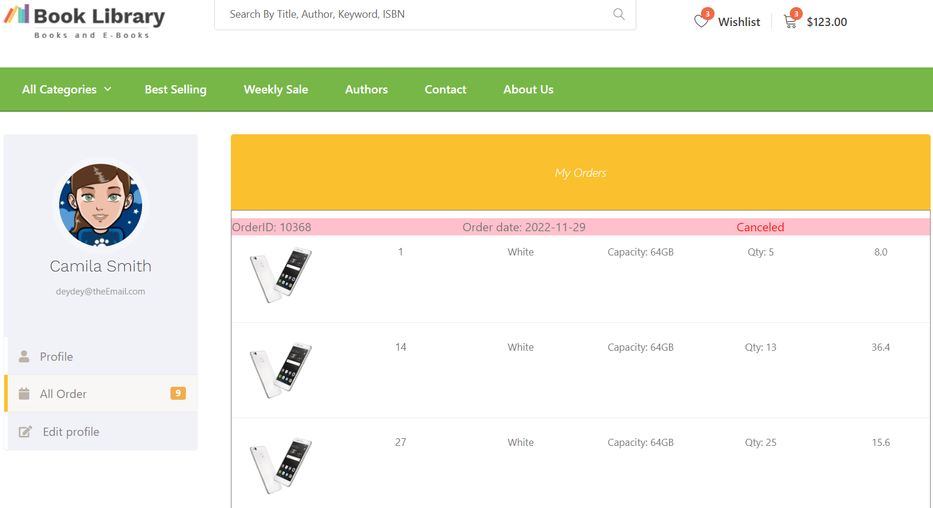

| ID and Name: | 04 – Manage Customer’s Order | Actor: | Customer |
| --- | --- | --- | --- |
| Description:  Trigger: | For user, the system will allow the user to check their order so far. | | |
| TThe user wants to check the list of products that the user has ordered. | | |
| Precondition: | PRE-1. Actors have been logged into the system.  PRE-2. Actors access personal profile screen | | |
| Post-conditions: | POST-1. The system displays the user's orders information. | | |
| Normal flow: | Actor actions | | System response |
|  | |  |
| Alternative Flows: | N/A | | |
| Exception Flows |  | | |
| Business Rules: |  | | |

## 4. Dashboard

1. Filter Revenue

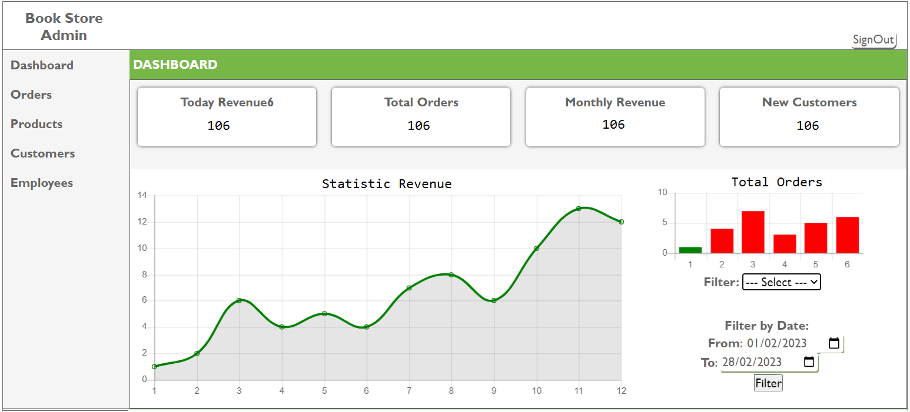

Figure 23: Filter revenue

| ID and Name: | 05 – Filter revenue | Actor: | Admin |
| --- | --- | --- | --- |
| Description:  Trigger: | This function allows the actor to view revenue of 12 month or 30 days of a month | | |
| Actor select a date on the calendar to choose “From ”date and “To” date and click on filter button | | |
| Precondition: | PRE_1: Actor has logged in the system with an admin account.  PRE_2: Actor accesses the account management page. | | |
| Post-conditions: | POST_1: The system displays a statistic diagram with data of revenue of 12 month or 30 days of a month | | |
| Normal flow: | Actor actions | | System response |
| 1. Click on the “From” calendar  3. Click on the “To” calendar  4. Click on the “Filter” button | | 2.System pop-up calendar to pick a day/month/year  3.System pop-up calendar to pick a day/month/year  5. The system displays a c statistic diagram with data of revenue of 12 month or 30 days of a month |
| Alternative Flows: | N/A | | |
| Exception Flows | N/A | | |
| Business Rules: |  | | |

b. Filter Order

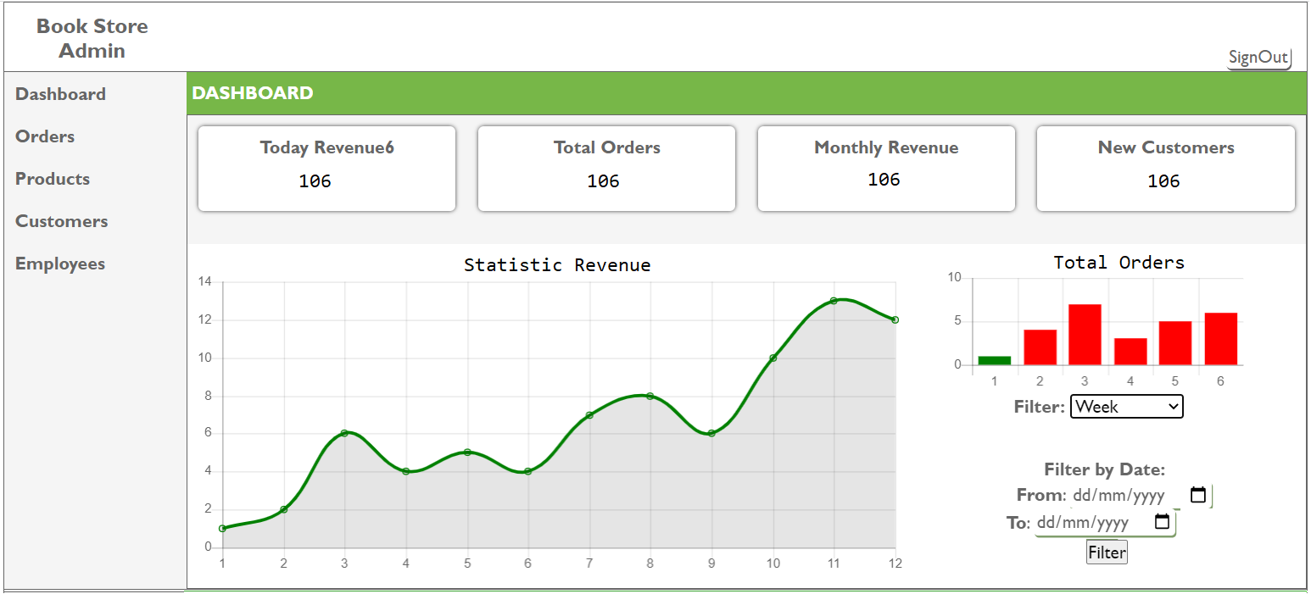

Figure 23: Filter Order

| ID and Name: | 05 – Filter Total Order | Actor: | Admin |
| --- | --- | --- | --- |
| Description:  Trigger: | This function allows the actor to view total order of nearest 6 months or 7 days of a week | | |
| Actor select on the dropdown list and click on Filter button | | |
| Precondition: | PRE_1: Actor has logged in the system with an admin account.  PRE_2: Actor accesses the account management page. | | |
| Post-conditions: | POST_1: The system displays a column diagram with data of nearest total orders in 6 months or 7 days of a week | | |
| Normal flow: | Actor actions | | System response |
| 1. Click on the select box  3. Choose week/month/year | | 2.System dropdown a list option  4. The system displays a column diagram with data of nearest 6 months or 7 days of a week |
| Alternative Flows: | N/A | | |
| Exception Flows | N/A | | |
| Business Rules: |  | | |

## 5. Products

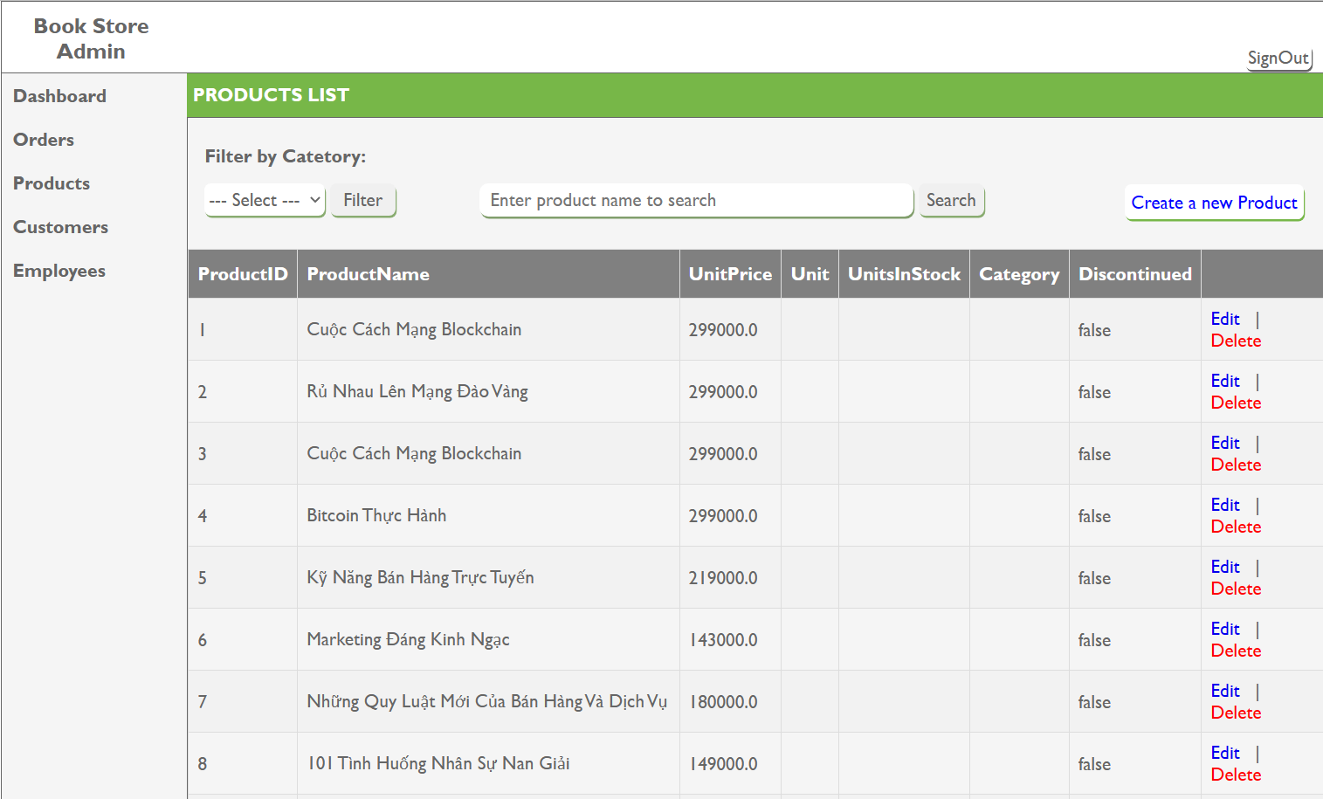

| ID and Name: |  | Actor: | Admin |
| --- | --- | --- | --- |
| Description:  Trigger: | This function allows the admin to add, edit and delete products | | |
| Actor can add, edit, delete, and update products with the "click" button. | | |
| Precondition: | PRE_1: Actor has logged in the system with an admin account.  PRE_2: Actor accesses the account management page. | | |
| Post-conditions: | POST_1: The system displays the product list | | |
| Normal flow: | Actor actions | | System response |
| 1. Click on the select box  3. Choose edit/delete/create | | 2.System dropdown a list option  4. The system displays the list according to the actor's wishes |
| Alternative Flows: | N/A | | |
| Exception Flows | EXC_1: ProductID does not exist | | |
| Business Rules: |  | | |

## 6. Orders

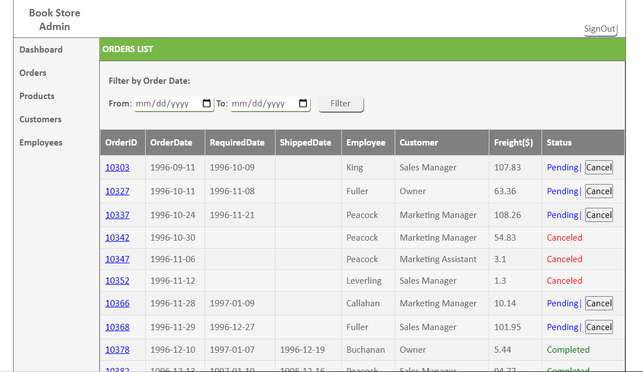

| ID and Name: | OrderManager_admin | Actor: | Admin |
| --- | --- | --- | --- |
| Description:  Trigger: | This function allows admin to monitor the progress of the order, the status of orders | | |
| The ACtor can view the status of the product, and can cancel the Orders with the "click" button. | | |
| Precondition: | PRE_1: Actor has logged in the system with an admin account.  PRE_2: Actor accesses the account management page. | | |
| Post-conditions: | POST_1: The system displays a list of order statuses, including completed orders, pending orders and orders that can be cancelled | | |
| Normal flow: | Actor actions | | System response |
| 1. sign in the system  3. Choose Cancel | | 2.System dropdown a orderlist  4. The system displays the list according to the actor's wishes |
| Alternative Flows: | N/A | | |
| Exception Flows | N/A | | |
| Business Rules: |  | | |

## 

## 7. Cart

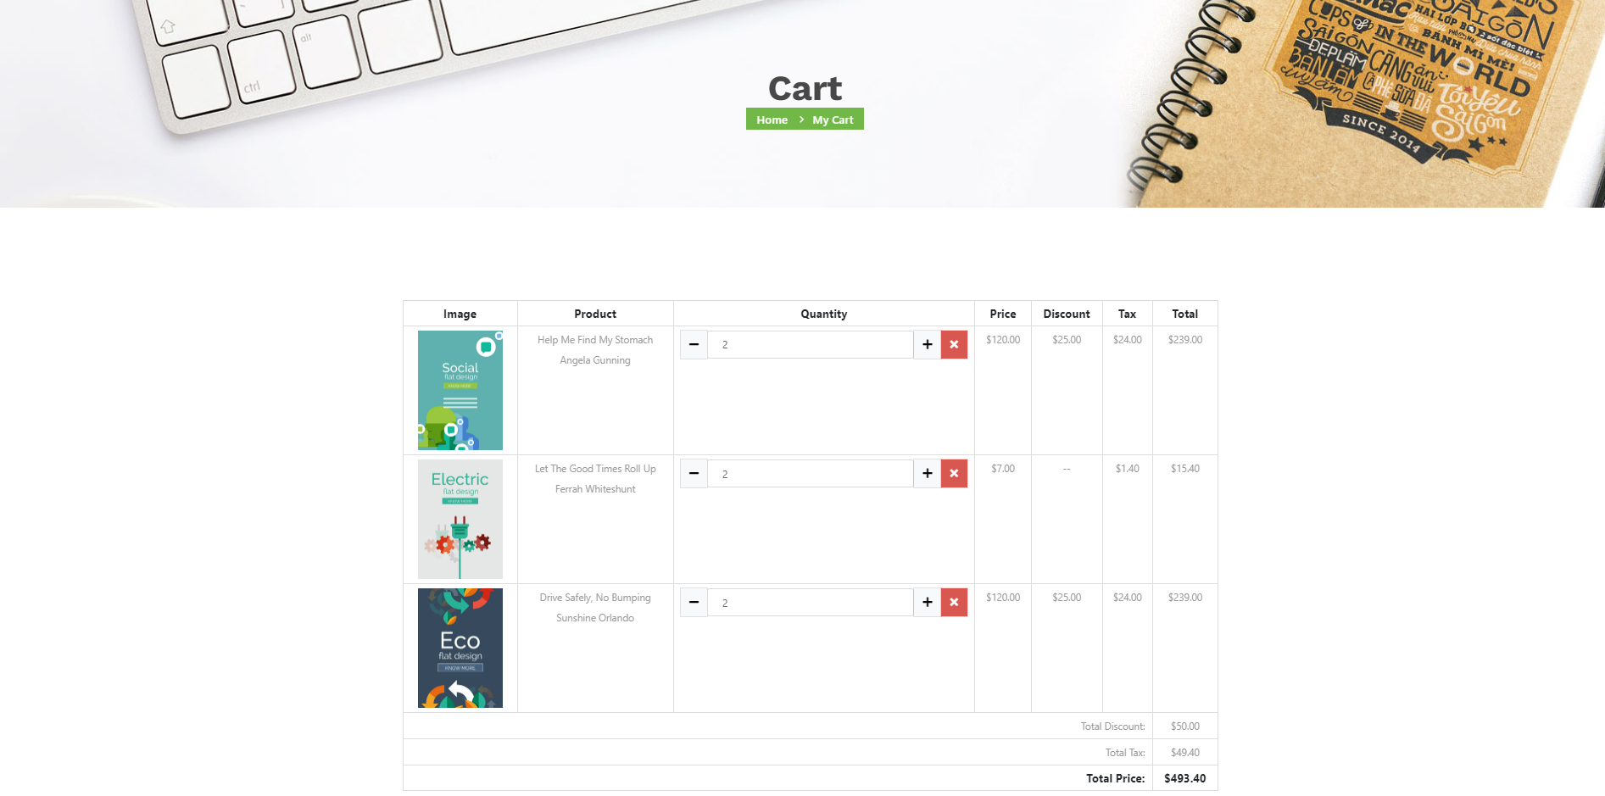

| ID and Name: | View cart | Actor: | Customer |
| --- | --- | --- | --- |
| Description:  Trigger: | This function allows customers to view any products in their cart before making a payment. | | |
| The customer clicks the cart icon or accesses the path of the cart page. | | |
| Precondition: | None | | |
| Post-conditions: | The system will redirect to Cart page to view their cart | | |
| Normal flow: | Actor actions | | System response |
| Click on cart icon on the header website | | System will display cart page’s view |
| Alternative Flows: | N/A | | |
| Exception Flows | N/A | | |
| Business Rules: |  | | |

## 